**Farmer Profiles: Northern Highlands, Coastal Cassava and Central Maize**

This brief presents profiles of Tanzanian farmers in three sub-regions of the country: northern, central and coastal. These profiles are based upon fieldwork conducted in the summer of 2011 in which EPAR staff interviewed farmers and farm groups in four areas in the Arusha and Kilimanjaro regions (Northern Highlands), in Pwani and Zanzibar areas of coastal Tanzania (Coastal Mixed Cassava), and Morogoro and Iringa areas of central Tanzania (Central Mixed Maize). The three sub-regions are depicted in the map below. In the sub-regions visited, groups of farmers responded to a series of questions designed to elicit a portrait of a ‘typical’ farmer in the area.

The brief first presents the farming systems present in each sub-region (see Appendix A for a complete list of farming systems as detailed by Tanzanian Ministry of Agriculture), then uses the Tanzania National Panel Survey (TZNPS), which was implemented by the Tanzania National Bureau of Statistics, with support from the World Bank Living Standards Measurement Study – Integrated Surveys on Agriculture (LSMS-ISA) team, to compare these sub-regions to the zones of which they are a part.[1] The profile for each sub-region is then presented.

Map for Karina - Trebuchet.pdfMore detail on the locations and number of respondents is given in Appendix B. While efforts were made to identify and visit “typical” farmers, respondents were often identified by agricultural extension officers and so are unlikely to be representative of the population of the sub-region.

**Farming System Overview – TZNPS Data**

*Northern Highlands*

The Northern Zone of Tanzania comprises four regions, Arusha, Kilimanjaro, Manyara and Tanga. The Northern Highlands sub-region includes the entire region of Kilimanjaro, and three districts in the Arusha region (Monduli, Arumeru, and Arusha districts), with a TZNPS sample size of 155 agricultural households.

The Tanzanian Ministry of Agriculture classifies these areas as a “Banana/Coffee/Horticulture” system, along with the highlands areas of Mbeya in southern Tanzania, and Kigoma and Kagera in western Tanzania. The system is characterized by highly intensive land use and small landholdings with significant land scarcity. In many of these areas in northern Tanzania, volcanic soils are highly fertile, farmers experience two rainy seasons, and irrigation systems are relatively common.

*Coastal Cassava*

The entire eastern border of Tanzania is Indian Ocean coastline, running from the Kenyan to the Mozambican border. The coastal areas are part of four administrative zones: Northern, Eastern, Southern, and Zanzibar. Each of these zones is quite large and includes inland and upland agro-ecological zones as well as coastal areas. From Zanzibar zone, the Coastal Mixed Cassava sub-region includes LSMS data from Zanzibar Island only. From the Eastern and Southern zones, the sub-region includes LSMS datafrom Pwaniand Dar es Salaam regions (agricultural households only) and the Kilwa district in the Lindi region. Of the 392 agricultural households in the sub-region, 143 are on Zanzibar. The Coastal Cassava regions that were visited in the field include Zanzibar and Pwani.

According to the Ministry of Agriculture, the “Cashew/Coconut/Cassava System” is found in the coastal regions of Lindi and Mtwara, among others. The Ministry characterizes this system as having relatively infertile soils, low rainfall, relative land abundance, and shifting cultivation.[2]

*Central Maize Region*

Interviews in the central area were conducted in northwestern areas of Morogoro region, and the northern areas of Iringa region. While relatively high when compared to central or western Tanzania, these areas were lower altitude than most of the Southern Highlands maize-belt. The Central Mixed Maize sub-region includes the Morogoro region, located within the Eastern Zone, and the Iringa Rural and Kilolo districts of Iringa region, located in the Southern Highlands Zone. The sample size was 122 agricultural households.

The central areas in Tanzania consist of mixed maize production, characterized by the Ministry asa “Maize/Legume System.” This system is found in many areas of Tanzania, including Rukwa, Ruvuma, Arusha, Kagera, Shinyanga, Iringa, Mbeya, Kigoma, Tabora, Tanga, Morogoro, Kahama, and Biharamulo. The Ministry characterizes this system as relatively land abundant, under shifting cultivation, and using an intercropping system of maize and legumes (typically beans and groundnuts).

|  |
| --- |
| Farming Household Profiles – TZNPS Data |

**Median Household**

In the Northern Highlands sub-region, the median household cultivated two plots on two acres, and grew a median of four crops. Sixty-two percent of households cultivated during both the long and short rainy seasons, and intercropping was very common with 81% of plots intercropped during the long rainy season. The majority of farmers planted the entire plot during the long rainy season, with only 6% of plots not planted in their entirety during the long rains.

The median household in the Coastal Mixed Cassava sub-region cultivated just one plot on two acres, and grew four crops. Forty percent of households in the region cultivated during both the long and the short rains and intercropping, while less common than in the Northern Highlands, was still practiced regularly, with 65% of plots intercropped in the long rains. Even with relatively small landholding size, 23% of households reported not planting their entire plot during the long rains.

Finally, the median household in the Central Mixed Maize sub-region cultivated two plots on three acres, and grew a median of three crops. Thirty-two percent, the lowest among the three sub-regions, of households in the region cultivated during both the long and the short rains and intercropping is common, with 66% of plots intercropped in the long rains. Eighteen percent of households reported not planting their entire plot during the long rainy season.

**Below Average Landholding**

The median landholding size in the Northern Highlands and Coastal sub-regions is two acres, and in the Central sub-region is three acres, compared to the national median of 3.25 acres (*Figure 1*). Median landholding in the Coastal sub-region, made up of districts in both Eastern and Zanzibar zones, is decreased by the especially low median in Zanzibar (1.5 acres). The median landholding size for the Central Mixed Maize sub-region, on the other hand, is similar to both Eastern Zone (2.75 acres) and the Southern Highlands Zone (three acres).

*Figure 1*: Median Household Landholding Size

**Zonal Cultivation of Maize, Paddy, and Cassava**

In the Coastal Mixed Cassava sub-region, cassava, paddy and maize are all common crops, with upwards of 40% of households cultivating each. Roughly half the paddy-cultivating households are located on Zanzibar. Banana, mango and coconut are also all commonly grown. Northern Highlands had high maize cultivation rates, but lower cassava and paddy cultivation. In addition to maize, 46% of households cultivated beans and 53% bananas. The Central Mixed Maize sub-region also has high maize cultivation rates and approximately one third of households cultivated paddy, bananas, and mangos (*Table 1*).

*Table 1*: Crop Cultivation Patterns in the Sub-Regions

|  |  |  |  |
| --- | --- | --- | --- |
| **Estimated Proportion of Households Cultivating Crops** | | | |
| Crop | Northern Highlands | Coastal Mixed Cassava | Central Mixed Maize |
| Maize | 85% | 43% | 78% |
| Cassava | 7% | 45% | 18% |
| Paddy | 8% | 41% | 32% |
| Banana | 53% | 39% | 40% |
| Mango | 25% | 33% | 38% |

When compared to other zones and sub-regions, households in the Coastal sub-region are more likely to grow cassava and paddy, and somewhat less likely to grow maize, whereas households in the Northern Highlands are far more likely to grow maize and much less likely to grow paddy or cassava (*Figure 2*).

*Figure 2:* Zonal Cultivation of Maize, Paddy and Cassava

Eighty-five percent of households in the Northern Highlands cultivate maize and the sub-region has the country’s second highest average maize yields in the long rainy season (300 kg/acre) after the Southern Highlands (*Figure 3*). Maize yields for the Coastal sub-region are driven by the non-Zanzibar observations, since maize is rarely grown in Zanzibar. Maize productivity in this sub-region is quite low, which may be due to low input use and heavy intercropping, which in turn may cause an underestimation of yields (given planting density) in the TZNPS data. Much of the coastal region also has relatively sandy and infertile soils. *Figure D.2* in Appendix D shows the distribution of maize yields in the Coastal Mixed Cassava Sub-Region, where about 45% of farmers have yields below 75kg/acre. Maize is the most commonly grown crop in the Central Mixed Maize sub-region, with 78% of households cultivating it, and yields are about average (270 kg/acre compared to national median of 267 kg/acre).

*Figure 3*: Median Maize Yield - Long Rainy Season

Paddy yields in the Coastal sub-region are substantially lower than other key rice-growing regions, with a median yield of 240 kg/acre compared to a national median of 450 kg/acre (*Figure 4*). The Central sub-region has higher yields, with a median of 400 kg/acre. See *Figure D.6* in Appendix D and *Figure E.3* in Appendix E for distribution of paddy yields in the Coastal and Central sub-regions.

*Figure 4*: Median Paddy Yield - Long Rainy Season

*Insufficient observations (less than 30) for Central, Lake and Northern zones as well as Northern Highlands sub-region

**High Land and Labor Productivity in the Northern Highlands**

The Northern Highlands sub-region also stands out for its productivity relative to other sub-regions and zones. The Northern Highlands has the highest total household land productivity of any sub-region/zone in Tanzania (*Figure 5*) – largely due to livestock contributions. Land productivity in the Central Mixed Maize sub-region is just below the national median, and lower than in most other zones. In particular, the land productivity for the sub-region is lower than both the Eastern and Southern Highlands zones, which suggests that the sub-region is bringing down the average in both zones (*Figure 5*).

*Figure 5*: Median Household Land Productivity for all Crops and Livestock

The Northern Highlands sub-region also has the highest median household labor productivity in the long rainy season of any sub-region or zone (*Figure 6*). Labor productivity in the Central sub-region is just below the national median, but higher than Eastern zone and lower than the Southern Highlands (*Figure 6*).

*Figure 6*: Median Long Rainy Season Household Labor Productivity

**Highest Input Use in the Northern Highlands**

The Northern Highlands sub-region had the second highest rate of organic fertilizer application, just below the Northern Zone (*Figure 7*).

*Figure 7*: Median Organic Fertilizer Application - Long Rainy Season

*Insufficient observations (less than 30) for Eastern and Zanzibar zones as well as Central sub-region.

The highest proportion of plots using improved variety maize seeds in both agricultural seasons was also in the Northern Highlands sub-region, with Northern Zone coming in a distant second (*Figure 8*).

*Figure 8*: Proportion of Plots Using Improved Variety Seeds for Maize in the Long and Short Rainy Seasons

*Insufficient observations (less than 30) for Zanzibar zone.

+Insufficient observations (less than 30) for the short rainy season for Central and Southern Zones as well as Coastal and Central sub-regions.

|  |
| --- |
| The Northern Highlands Sub-Region |

*Table 2:* Farm Characteristics of the Northern Highlands Sub-Region

|  |  |  |
| --- | --- | --- |
|  | **Northern Highlands** | |
| Number of agricultural households | N=155 | |
|  | Median | Mean |
| Number of plots | 2 | 1.66 |
| Total landholding size (acres) | 2 | 3.12 |
| Number of crops cultivated by household | 4 | 4.25 |
|  | Estimated Proportion | |
| Female-headed agricultural households | 28.75% | |
| Households that cultivate only in the long rainy season (of households that cultivate at least one plot) | 33.03% | |
| Households that cultivate in *both* the long and short rainy seasons (of households that cultivate at least one plot) | 62.41% | |
| Households that own farm implements | 89.26% | |
| Plots intercropped in the long rainy season | 81.45% | |
| Plots not planted in their entirety in the long rainy season | 6.19% | |

*Insufficient observations (less than 30) to provide reliable mean, median or proportion

Part of the Northern Zone of Tanzania consists of highland areas, located largely in Arusha and Kilimanjaro regions. These highland areas are designated as a “banana/coffee/horticulture” farming system by the Ministry of Agriculture and in this brief we characterize them as the ‘northern highlands sub-region.’ Below we create profiles of “typical” highlands farmers based on site visits and interviews with farm groups in two areas in Arusha and Kilimanjaro districts.

**Districts in Arusha Region**

The Arusha region consists of six districts. The Arusha interviews took place in Arumeru district in the villages of Patandi and Kipande near Mount Meru.

**Districts in Kilimanjaro Region**

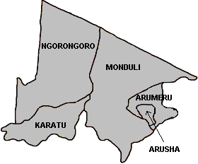

The Kilimanjaro region consists of six districts, including Moshi town. The Kilimanjaro interviews took place in Hai district in Nkuu Sinda village. The main ethnic group in this area is the Chagga.

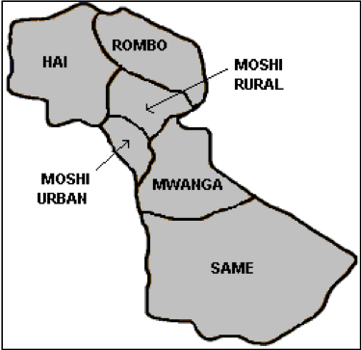

All of these areas are located at relatively high altitude on the slopes of Mt. Meru or Mt. Kilimanjaro, experience two rainy seasons per year, and often have access to irrigation, usually through irrigation furrows. Appendix B gives additional information on the areas and the farmers interviewed.

Along with the data from the field interviews, we present data drawn from the TZNPS survey. These data represent all the available household data from the Kilimanjaro region, along with data from the districts of Arumeru, Mondoli and Arusha in Arusha region. The TZNPS data present a more representative picture of farming systems in the area and provide a check on how ‘typical’ interviewed farmers were. Note, however, that these data are drawn from smaller sub-sets of the sampling frame for the TZNPS and therefore cannot be considered representative of these regions.

**The “Typical” Northern Highlands Farm Household**

The typical farmer in the northern zone highlands sub-region farms a relatively small landholding in his or her traditional home area. According to farmers, the typical homestead landholding is between 0.5 and 1.0 acres. Most of this land is inherited, with ownership recognized through traditional tenure systems. In addition to home cultivation, many households cultivate a separate plot of maize, often located at lower altitudes some distance from the home. According to respondents, these plots typically range from 0.5 to 2 acres in size, smaller than the overall Northern zonal average median landholding of 3.0 acres. Farmers report that a key management decision they must make each year is how to balance their efforts and inputs between the home and the away plots. While upland home plots are often irrigated, maize planted on distant plots is usually not irrigated, so must be cultivated during the long rains “masika” season.

The “Home” Plot

The average half acre home plot is densely planted and intercropped, and is typically cultivated year-round, often with some sort of furrow irrigation available. According to TZNPS data for the sub-region, upwards of 80% of plots are intercropped during the long rains (*Table 2*). The median household reported cultivating four crops in the 2008 agricultural season, and nearly 2/3 of households cultivated in both the long and the short rains. Maize is the most frequent crop grown on at least one household plot, followed by beans. Interviews in the field suggest that cultivation of the home plot is nearly year round in the highland areas, due to the high rainfall and the availability of water for irrigation. The availability of irrigation on the farms visited suggests that the interviewed farmers may not be ‘typical’ in this regard; TZNPS data for this sub-region suggest about 16% of plots are irrigated.

**A mixed banana/yam/legume system in Kilimanjaro**

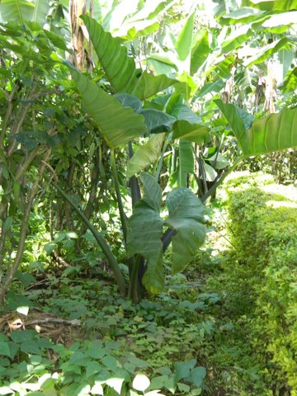

Bananas are a key home plot crop for many families in the areas visited and are farmed essentially as permanent crops. The typical home plot is intercropped seasonally with vegetables, legumes, cassava, yams and sometimes a small amount of maize for home consumption. Planting and intercropping strategies are complex, with decisions based on the season, the age of banana and fruit trees (and thus their canopy size), and the timing of labor requirements for the maize plot. Plots are often ringed with fruit trees (usually avocado and papaya) on the plot border. Papayas are grown largely for home use, but avocados are often sold.

Bananas are grown by just over 50% of households, according to the TZNPS data for the sub-region. The choice of crops to intercrop with banana trees varies with the age of the trees. Tree age must be balanced with seasons – both in terms of the rains and the cold, which can be severe at highland altitudes. According to farmers, maize and legumes are best planted at the start of the long rainy season in February or March and harvested in June. Vegetables are best planted in July or August, and harvested up until the start of the next long rainy season in March. Cassava and yams also do best when planted at the start of the long rains, but often farmers replant at the time of harvest, regardless of the timing of the rains.

Banana trees typically take about 18 months to mature. Once bananas have been harvested, the main trunk is cut down and the smaller side suckers are left to re-grow. At this time, maize and beans might be planted in the area surrounding the banana tree, to take advantage of the smaller canopy—assuming that the timing is good in terms of rain and cold. As the banana trees grow, intercropped crops must move farther and farther away from the shade canopy and maize is less easily grown. While farmers recognize that intercropping maize with bananas is not a recommended strategy, many report that they like to have some maize on the home plot for home consumption, often for roasting on the cob.

Some farmers try to plant all the banana trees at the same time to make irrigation more efficient. Under this strategy, the area around the young banana trees is planted with vegetables and maize and the irrigation water then feeds both the bananas and other crops. Other farmers prefer to stagger their bananas so that they can harvest continually. The organization of cultivation on the plot also varies. Some farmers prefer to plant in rows and to follow recommended spacing strategies for various crops; others plant somewhat more opportunistically: as one crop is harvested (for example beans or cowpeas) a different crop might be planted in its place. While high rainfall can support near continual cultivation in this area, many vegetables and legumes do not do well during the cold season in June and July.

*Figures 8* and *9* show two potential intercropping systems for the sub-region. These plot maps were drawn together with farm groups, using both their reported knowledge and walks through existing farms. *Figure 10* shows a half-acre plot planted in rows, with bananas as a main crop. *Figure 9* shows a more ‘opportunistic’ intercropping strategy, in which farmers plant in a somewhat more random pattern and typically change the choice of intercrop over the course of a year or as banana trees mature. These systems appear to have a focus on cassava, yams and legumes.

*Figure 9*: Typical 0.5 Acre Banana Plot

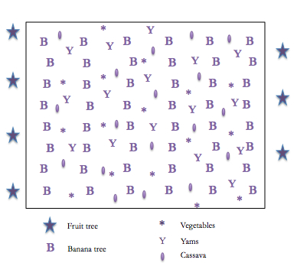

Input Use

*Figure 10*: Typical 0.5 Acre Banana Plot

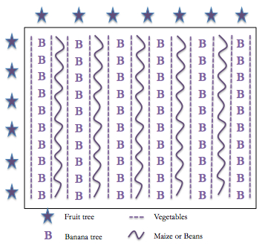

Farmers reported that inorganic fertilizers are rarely used on the home farm, in part because of the relatively high perceived fertility of the soil, in part because of the constant rotating and intercropping makes fertilizer application infeasible, and in part because of the availability of organic fertilizer from livestock. As noted above, the northern region has relatively high organic fertilizer application rates and all interviewed farmers reported using some organic fertilizer, typically cow manure, on their home farms. The TZNPS data suggest that in the northern highlands sub-region, organic fertilizer was applied to 38% of plots in 2008 (*Table 3*).

*Table 3*: Input Use in the Northern Highlands Sub-Region - TZNPS Data

|  |  |  |
| --- | --- | --- |
| **Fertilizer and Pesticide/Herbicide Usage** | | |
|  | Median | Mean |
| Estimated proportion of plots that apply organic fertilizer | 38% | |
| Organic fertilizer applied kilograms/acre (long rainy season) | 450 | 987 |
| Main crop that organic fertilizer is applied to | Maize | |
| Estimated proportion of plots that apply inorganic fertilizer | 22% | |
| Inorganic fertilizer applied kilograms/acre (long rainy season) | 50 | 44 |
| Main crop that inorganic fertilizer is applied to | Maize | |
| Estimated proportion of plots that apply pesticides/herbicides | 33% | |
| Herbicides applied kilograms/acre (long rainy season) | 0.5 | 1 |

Secondary Maize Plots

Respondents reported that a large proportion of households in the area cultivated plots of maize in lower, warmer areas, close to the main tarmac road running from Arusha to Moshi. Some of this land is inherited, some has been purchased, but a large proportion is rented by the season. Maize in these areas is planted in February and harvested in August. Improved seeds and inorganic fertilizers are commonly used on these plots, which are typically managed jointly by husbands and wives. These plots are often located at some distance from the home, so that during peak labor periods all household labor is concentrated on the maize plot, which must often be reached by bicycle or motorized transport. Data from the 2008 TZNPS survey confirm that maize is an important crop in the sub-region, grown by 85% of households (*Table 5* below).

As noted above, each year farm households must decide what resources to put into the maize plot. Since there is no irrigation in the maize cultivation areas, production is much riskier than in the home plot which is higher, wetter, and often has access to irrigation. Perhaps as a result, the intensity of cultivation in the maize plots appears to vary widely. Respondents suggested that wealthier farmers, perhaps better able to bear risk, can cultivate more intensively and yield a higher return when the rains are good. Those with larger maize plots farm by tractor and use hired labor, and sometimes herbicides, for weeding. Those with smaller plots typically intercrop with beans and weed by hand. Labor appears to be a real constraint for these maize plots – many households hire labor to supplement their household labor during peak periods of weeding and harvest. Daily wage labor is easily found in this region, as many individuals have migrated here from other areas in Tanzania and many of these plots are near a main road. Most farmers report that children are not available to engage in agricultural labor because they are in school. Many households sell surplus maize from these plots after taking what is needed for home consumption.

The TZNPS data confirm that yields in the sub-region vary (*Table 5*). The median maize yield of 308 kgs/acre is similar to the overall median for the Northern Zone, though the higher mean value suggests there are a few highly productive farmers, as is shown in the distribution in *Figure C.2* in Appendix C. A relatively high proportion of plots are planted with improved varieties of maize seed – 48% in this sub-region as compared with 33% in the Northern Zone as a whole and 16% nationally in the long rainy season. Mean yields for this sub-region are slightly below the Northern Zone average of 416 kg/acre, but above the national mean of 367 kg/acre.

*Table 5:* Cultivation Patterns in the Northern Highlands Sub-Region - TZNPS Data

|  |  |  |  |
| --- | --- | --- | --- |
| **Cultivation** | | | |
| Crop |  | Median | Mean |
| Most prevalent crop in profile region | Maize |  | |
| Maize | Estimated proportion of households that cultivate | 85.46% | |
| Harvested area yield in the long rainy season (kg/acre) | 308 | 399.10 |
| Area harvested with maize in the long rainy season (acres) | 1 | 1.41 |
| Estimated proportion of plots using improved variety seeds for maize in the long rains | 48% | |
| Beans | Estimated proportion of households that cultivate | 46.13% | |
| Harvested area yield in the long rainy season (kg/acre) | 67 | 103.55 |
| Area harvested with cassava permanent crop (acres) | 0.75 | 1.10 |
| Bananas | Estimated proportion of households that cultivate | 52.5% | |
| Coffee | Estimated proportion of households that cultivate | 36% | |
| Paddy* | Estimated proportion of households that cultivate | 7.83% | |
| Cassava* | Estimated proportion of households that cultivate | 7.16% | |

*Insufficient observations (less than 30) to provide reliable mean or median.

N=155 Agricultural Households

To illustrate the range of maize yields in the area, *Table 6* shows costs and revenues for two hypothetical maize plots located in these areas, based on data reported by farmers in field interviews. The ‘typical’ farmer has a smaller landholding, and can farm less intensively than the hypothetical “model” farmer who has sufficient capital for high intensity production. The smaller farmer actually receives a negative return on the maize plot, even before factoring in the value of the farmer’s own labor. The data on the table are based on the harvest in 2010, a year in which farmers in the area reported that the rains were good. The table suggests that in such years the return to high intensity farming is relatively high. But high intensity farming is risky as well. One of the ‘model’ farmers on which this data are based reported that in 2011 he expected virtually no harvest from his maize plot due to poor rains. His plan was to grind up the maize cobs to feed to his cattle.

***Table 6:* "Typical" Maize Inputs and Yields in the Northern Highlands Sub-Region**

|  |  |  |  |  |  |
| --- | --- | --- | --- | --- | --- |
| **Model Farmer - 1 acre of maize** | | | **Typical Farmer - 0.5 acre of maize** | | |
|  | **Tsh** | **USD** |  | **Tsh** | **USD** |
| Owns land |  | 0 | Land rental and plowing | 16,000 | 10 |
| Land prep - tractor | 25,000 | 16 |  |  |  |
| Improved seeds | 15000 | 10 | Improved seeds | 10000 | 6 |
| Fertilizer - DAP, 1.5 bags | 37500 | 24 | Fertilizer - DAP | 0 | 0 |
| Fertilizer - urea, 3 bags | 135,000 | 87 | Fertilizer - urea, 0.5 bag | 14,000 | 9 |
| Hired labor, planting | 25,000 | 16 | Own labor for planting |  |  |
| Weeding labor, two weedings | 50,000 | 32 | Weeding labor, two weedings | 20,000 | 13 |
| Hired labor, harvesting | 25,000 | 16 | Own labor for harvesting |  |  |
| Transport for harvested maize | 50,000 | 32 | Transport for harvested maize | 20,000 | 13 |
| Cob removal for 25 bags | 37500 |  |  |  |  |
| **Total Costs** | **464,275** | 300 | **Total Costs (without own labor)** | **80,000** | 52 |
|  |  |  |  |  |  |
| Price received per 100kg bag | 45,000 | 29 | Price received per 100 kg bag | 35,000 | 23 |
| Reported per acre yield in 100 kg bags | 25 |  | Reported per half acre yield in 100 kg bags | 3 |  |
|  |  |  |  |  |  |
| **Net revenue from 1 acre** | **660725** | **426** | **Net revenue from .5 acre** | **25000** | **16** |

The TZNPS data confirm that yield varies among farmers in this sub-region. *Figures C.2* and *C.3* in Appendix C show the distribution of maize and beans yields for the sub-region, bearing in mind that the number of observations is relatively low and not statistically representative.

Productivity rates for the sub-region are also somewhat widely distributed. At $96 per acre, median land productivity (without the value of livestock) is lower than the Northern Zone average, although the mean is substantially higher ($172). The mean land productivity without livestock for Tanzania as a whole is $95/acre. *Figure C.4* in Appendix C shows the distribution of land productivity in the sub-region.

*Table 7*: Productivity for the Northern Highlands Sub-Region - TZNPS

|  |  |  |
| --- | --- | --- |
|  | Median | Mean |
| Land productivity w/out livestock (US dollars/acre) | $96 | $171.87 |
| Land productivity w/livestock (US dollars/acre)* | $150 | $282.79 |
| Labor productivity in the long rainy season (US dollars/day) | $1.37 | $2.49 |

*Note: The data does not provide information on land used for livestock, so livestock value has been added to the numerator, but no additional land is included in the denominator.

Labor and Seasonality

While landholdings in this area are small, cultivation is typically intensive. Bananas, coffee, cassava, and yams are grown throughout the year, while maize and legumes are planted during the long rains, and vegetables during the short rains. As *Figure 11* indicates, labor requirements are high throughout the year, although they peak at the end of the long rains, when maize must be harvested and the coffee harvest starts, for those farmers with coffee trees. Given that many maize plots are located at a distance from the home, during peak labor times for maize, home plots cannot be as intensively cared for without the use of hired labor. Most farmers interviewed reporting hiring some casual labor for maize land preparation and weeding.

*Figure 11*: Seasonal Calendar - Bananas/Horticulture/Coffee

|  |  |  |  |  |  |  |  |  |  |  |  |  |
| --- | --- | --- | --- | --- | --- | --- | --- | --- | --- | --- | --- | --- |
|  | **Jan** | **Feb** | **Mar** | **Apr** | **May** | **Jun** | **Jul** | **Aug** | **Sep** | **Oct** | **Nov** | **Dec** |
| Plot 1: Maize – non-local plot |  | Plow | Plant |  | Weed | Weed | Weed | Harvest |  |  |  |  |
| Plot 2:Maize and legumes – home plot |  |  | Plant | Weed | Weed | Harvest |  |  |  |  |  |  |
| Plot 2:Vegetables | Harvest | Harvest |  |  |  |  |  | Plant | Weed | Harvest | Harvest | Harvest |
| Plot 2: Coffee |  |  |  |  |  |  |  | Harvest | Harvest | Harvest | Harvest | Harvest |
| Plot 2:Cassava/ Yams | Constant rotating production  Constant rotating production | | | | | | | | | | | |
| Plot 2: Bananas |

Livestock

Livestock form an integral component of the farm management system for most farmers interviewed. Respondents reported that most households own at least one hybrid/improved cow or bull, and respondents reported that most homes had roughly 2-4 cattle. Given the scarcity of land, farmers reported that cattle were typically kept in pens, using a ‘zero grazing’ system in which food is brought to the animals. Much of the vegetable waste matter from the farm is used for this purpose, including the leaves and stems of banana trees and post-harvest maize stalks. At the harvest season, trucks loaded with dried stalks can be seen leaving the maize fields near the road, headed up to the highland homesteads. Households with larger landholdings often grow napier grass as a cattle feed, both for sales and for own consumption.

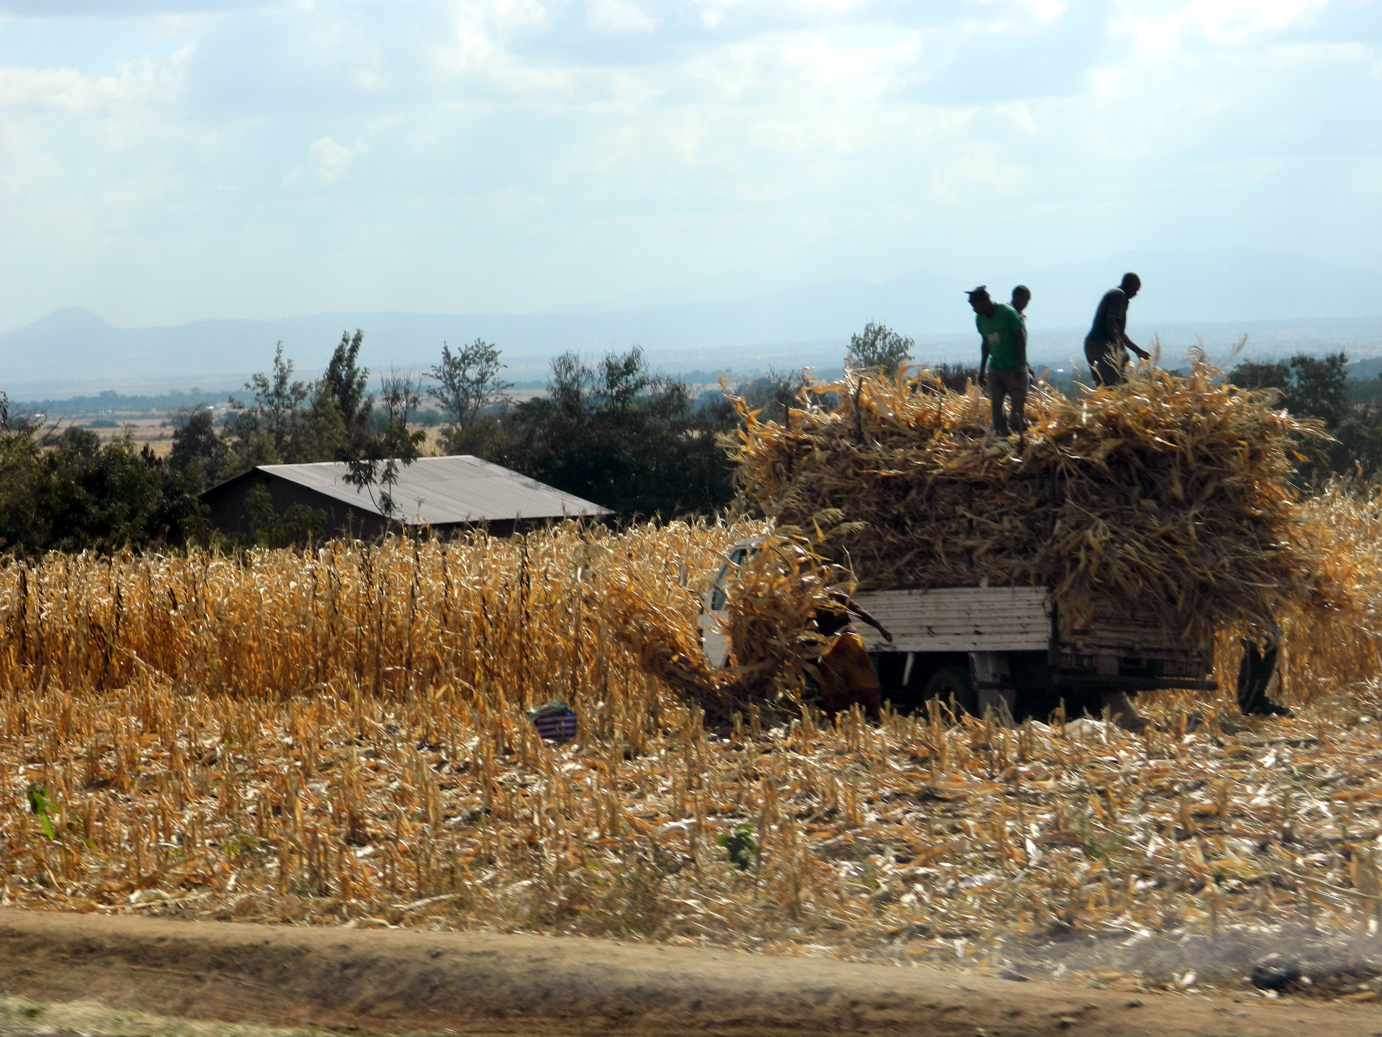

**Dried maize stalks are loaded onto trucks for transport to homes for use as livestock feed**

*Table 8* shows that nearly 54% of households in the sub-region owned cattle, with a median herd size of three. This rate of ownership is well above the national median of 25% and the rate for the Northern Zone as a whole (47%) but median herd size is lower than the national median of just over five, and the Northern Zonal median of four cattle.

The availability of manure from cows, goats and chickens under a ‘zero-grazing’ system likely accounts for the high application rates of organic fertilizer in the area (see *Figure 7*).

Livestock by-products, chiefly milk and eggs, are an important source of household income as well, and contribute to the high value of agricultural production. In addition to the value of by-products, many farmers report that the sale of calves is an important source of income. Land constraints prevent most household from keeping large herds, so that calves are often sold at 6 months and currently fetch between $200-$350 an animal, depending on the breed.

In some areas, farmers report that goats are becoming an increasingly important source of income – both from sales of milk and from sales of kids. The TZNPS data confirm that goat ownership is important in this sub-region. *Table 8* shows that 50% of households own goats, with a median herd size of four animals, as compared to the national ownership rate of 30%. Goats are favored by farmers for their quick reproduction rates. Goats typically give birth twice a year and often have twins and farmers report that kids can be sold at 3 months for roughly $75. Some farmers claim goats are easier to keep than cattle, as they can eat a wider variety of food and require less space. Most household also own chickens, which are typically traditional varieties. Eggs are used both for home consumption and for sale, depending on the size of the brood.

*Table 8*: Livestock Ownership in the Northern Highlands Sub-Region - TZNPS Data

|  |  |  |
| --- | --- | --- |
| **Livestock** | | |
|  | Median | Mean |
| Estimated proportion of households owning cattle | 53.63% | |
| Number of cattle owned | 3 | 5.61 |
| Estimated proportion of households owning improved cows | 33.70% | |
| Number of improved cows owned* | 1 | 1.32 |
| Estimated proportion of households owning goats | 50.11% | |
| Number of goats owned | 4 | 8.79 |
| Estimated proportion of households owning improved goats | 6.42% | |
| Number of improved goats owned* | 2 | 21.45 |
| Estimated proportion of households owning chickens | 72.30% | |
| Number of chickens owned | 10 | 12.38 |

*Insufficient observations (less than 30) to provide reliable mean or median

Horticulture

Horticulture for cash sale is an increasingly important source of income in this area. Many NGOs are working with farmers to grow high-value horticultural crops for sale in the urban markets of Moshi and Arusha. For example farmers we spoke with in the Mount Meru area were growing vegetables for sale to the ShopRite supermarket in Arusha. Other farmers are working with private firms, increasingly under contract.

Where vegetable cultivation is intended for sale as a horticultural crop, it is often cultivated in a separate plot, or a separate portion of a plot, rather than intermixed. Farmers typically specialize in one type of horticultural crop, often in response to NGO or private firm initiatives. NGO agricultural staff reported that horticulture outgrower schemes were proliferating in the area, with firms often competing for access to farmers. This has at times led to perverse outcomes, with farmers breaking contracts when a more favorable offer comes along, as well as firms breaking contracts when higher quality products can be found. Many of the ‘contracts’ appear to be verbal, which may contribute to problems in contract fulfillment. Extension officers also noted that farmers take some time to become familiar with the produce grading system, and as a result sometimes feel they are being cheated if their product receives a low quality rating.

The most consistent complaint heard from farmers engaged in horticulture concerned the challenges of finding a steady and reliable market. Most farmers in the region felt that it was relatively easy to grow horticultural vegetables, but marketing was a challenge. The constraints most often mentioned were:

* Seasonality – produce all reaches maturity at the same time, and is perishable, so the market price received is low.
* Informal contracts – most farmers interviewed had informal contracts for their produce. They would talk to a buyer who would agree to buy a certain amount at a certain date, but when the produce was brought, farmers would find someone else had gotten there first.
* Foreign competition – this was a particular complaint about tomatoes. Farmers complained that they tried to grow tomatoes for local canning operations, but found that they were being undercut by lower cost tomatoes from China and India.
* Access to irrigation – Many farmers noted that the availability of irrigation was a key limiting factor in expanding the area that could be used for horticulture.
* At higher altitudes, another key constraint is finding horticultural products that can grow during the cold season, when, although rainfall is high, soils remain very cool.

Farmers perspectives differed from those of agricultural and NGO agents regarding previous experiences with horticulture. The extension workers often felt that farmers were not being entrepreneurial enough, or were slow to take advantage of new market opportunities. Farmers clearly felt ‘burned’ by previous efforts to market new crops they had successfully grown, and were somewhat reluctant to specialize in one horticultural product. From the perspective of the EPAR interviews undertaken in the three regions, however, the northern highlands farmers were clearly the most entrepreneurial. Most households managed a complex set of agricultural and livestock activities, and appeared relatively open to new market opportunities.

Coffee

Coffee cultivation was a contentious topic in the northern highlands sub-region. The Arusha and Kilimanjaro areas have traditionally been important coffee growing areas, but many smallholders we spoke with reported that they have moved away from coffee production due to the low price received for processed beans and the high costs of inputs. Among those farmers that still grow coffee, few appeared to cultivate a pure stand, instead mixing coffee with bananas and vegetables. While mitigating risk, many farmers also recognized that intercropping was likely affecting their coffee yields. Although coffee prices have recovered somewhat in recent years, many farmers remain wary of coffee production, since the high cost of inputs renders them vulnerable to even small changes in price.

At higher altitudes, farmers reported that one challenge to coffee production is the longer harvest period due to colder temperatures. Since beans must be dried and processed relatively quickly, coffee farmers at these higher elevations must spend a relatively longer period of time processing relatively small amounts of coffee.

Finally, farmers perceive the coffee cooperatives as another constraint to coffee production. Farmers perceive that there is a large margin between the price they are paid, and the market price, and do not perceive high benefits flowing from the cooperative.

Intra-Household Management

Most farmers – both male and female – agreed that the most common farm management strategy was for women and men to jointly manage their farm, including both home plots and more distant maize plots. This does not mean that all members engage in all farm activities. Most families appear to discuss all farm management together to agree on a division of labor, which could include joint cultivation or specialization by spouse. Some gender differentiation in crops and livestock seems to be relatively clear, although no farmer reported exclusively ‘wife’ or ‘husband’ ownership of specific plots. Men still typically manage the harvest and receive the income from sales of maize, cattle and sometimes horticultural crops, while women make more management decisions and receive income from sales of chickens and eggs, bananas, home vegetables and livestock by-products such as milk. For many families, however, the overall farm management strategy appears to be a joint strategy.

Both male and female farmers in this region were united in their opinion that the situation for women has improved greatly in recent years. Farmers attribute this to the fall in the relative prices of male-dominated crops (especially coffee) relative to female-dominated crops, which include bananas, milk products, and chickens and chicken by-products. Coffee was traditionally a crop owned by men, who supervised production and received the proceeds from the harvest. Older farmers noted that in this situation, women were beholden to their husbands for whatever share of the harvest proceeds he allocated to them. The sale of bananas, milk and chickens, on the other hand, has traditionally been reserved for women. As one male farmer put it, “I would not be seen in the market with a chicken.” Men remain largely in charge of the sale of cattle and goats. As bananas, milk, and eggs become increasingly larger components of household income, women’s power within the household has increased, according to respondents.

Farmer-Reported Constraints to Production

The primary constraints to production reported by farmers varied more in this sub-region than in other areas. As in other areas visited, “capital” was the most common first response to any question about farming constraints, although finding a steady and reliable market was a common complaint in this sub-region as well, perhaps due to the increasing competition for markets for horticultural produce. A shortage of land was also noted as a key constraint, especially for those farm families who did not have access – either through ownership or rental – to additional lowland plots for cultivating maize.

Many farmers noted the high maize yields that could be obtained through good land preparation, use of improved seeds and fertilizer, and proper weeding, although they noted that not everyone had the capital to cultivate with this level of intensity. For maize cultivation, adequate rainfall was the key risk most farmers felt they had to deal with.

|  |
| --- |
| The Coastal Mixed Cassava Sub-Region |

The entire eastern border of Tanzania is Indian Ocean coastline, running from the Kenyan to the Mozambican border. The coastal areas are part of four administrative zones: Northern, Eastern, Southern, and Zanzibar. Eastern zone also includes greater Dar es Salaam. Each of these zones is quite large, and includes inland and upland agro-ecological zones, as well as coastal areas. The coastal mixed cassava sub-region is comprised of the easternmost regions within each of these zone and includes Zanzibar Island, Pwani region in the Eastern Zone, Kilwa district in the Lindi region of the Southern Zone and the agricultural households in the Dar es Salaam region of the Eastern Zone. Of the 392 agricultural households in the sub-region, 143 are on Zanzibar.

*Table 9:* Farm Characteristics of the Coastal Mixed Cassava Sub-Region

|  |  |  |
| --- | --- | --- |
|  | **Coastal Mixed Cassava** | |
| Number of agricultural households | N=392 | |
|  | Median | Mean |
| Number of plots | 1 | 1.41 |
| Total landholding size (acres) | 2 | 4.36 |
| Number of crops cultivated by household | 4 | 4.08 |
|  | Estimated Proportion | |
| Female-headed agricultural households | 21.48% | |
| Households that cultivate only in the long rainy season (of households that cultivate at least one plot) | 56.38% | |
| Households that cultivate in *both* the long and short rainy seasons (of households that cultivate at least one plot) | 40.43% | |
| Households that own farm implements | 74.39% | |
| Plots intercropped in the long rainy season | 65.46% | |
| Plots not planted in their entirety in the long rainy season | 23.04% | |

*Insufficient observations (less than 30) to provide reliable mean, median or proportion

As *Table 10* shows, the mean yields are typically well above the median for the three priority crops.

*Table 10*: Median and Mean Yields in the Coastal Sub-Region = TZNPS Data

|  |  |  |  |
| --- | --- | --- | --- |
| **Crop Yields** |  | Median | Mean |
| Cassava | Harvested area yield for permanent crop (kg/acre) | 353 | 422.18 |
| Area harvested with cassava permanent crop (acres) | 1.5 | 3.35 |
| Maize | Harvested area yield in the long rainy season (kg/acre) | 100 | 144.43 |
| Area harvested with maize in the long rainy season (acres) | 1.5 | 1.97 |
| Paddy | Harvested area yield in the long rainy season (kg/acre) | 240 | 297.58 |
| Area harvested with paddy in the long rainy season (acres) | 1 | 1.52 |

Cassava yields in Zanzibar Zone (including both Zanzibar and Pemba islands) and in the Coastal Sub-Region more generally are relatively high compared to other regions where cassava is widely grown (*Figure 12*). The distribution of yields (shown in *Figure D.3* in Appendix A) suggests that about 25% of farm households have very low cassava yields, which may be due in part to more frequent intercropping by these households.[3] The mean and median yield for the sub-region as a whole is lower, suggesting that Zanzibar Zone is relatively productive compared to the mainland. *Figures D.4* and *D.5* in Appendix A confirm this and show that Zanzibar Zone in general has higher cassava yields than the mainland, with yields more evenly distributed and fewer very low productivity households. In addition, because cassava is considered a perma crop in many households and is harvest continuously for home consumption, one-time farmer recall measurements may understate the amount harvested annually.

*Figure 12:* Median Cassava Yield - Permanent Observations

Note: Data for Coastal Sub-Region includes Zanzibar Island.

Input use in this sub-region appears low. Only seven percent of plots used organic fertilizer and five percent applied inorganic. Eighteen percent of households report using improved variety seeds of maize, but again maize is not a key staple in many of these areas. Rice paddy is the most common crop that receives inorganic fertilizer.

*Table 11*: Coastal Sub-Region Input Use

|  |  |  |
| --- | --- | --- |
|  | Median | Mean |
| Estimated proportion of plots that apply organic fertilizer | 7% | |
| Organic fertilizer applied per acre (long rainy season) | 250 | 609 |
| Main crop that organic fertilizer is applied to | Maize | |
| Estimated proportion of plots that apply inorganic fertilizer | 5% | |
| Main crop that inorganic fertilizer is applied to | Paddy | |
| Estimated proportion of plots that apply pesticides/herbicides | 8% | |
| Estimated proportion of households using improved variety seeds for maize | 18% | |

**Coastal Mixed Cassava Sub-Region Profile**

In this section we create profiles of “typical” farmers based on field interviews conducted on Zanzibar and in Pwani district on the mainland. Zanzibar consists of two islands, Unguja and Pemba, although common usage refers to Unguja as Zanzibar Island. The island consists of three administrative regions: [Zanzibar Central/South](http://en.wikipedia.org/wiki/Zanzibar_Central/South), [Zanzibar North](http://en.wikipedia.org/wiki/Zanzibar_North) and [Zanzibar Urban/West](http://en.wikipedia.org/wiki/Zanzibar_Urban/West). Interviews with farmers took place in Zanzibar Urban/West and Zanzibar Central/South. The urban/west region is relatively fertile and has two rainy seasons; the south is dry, with rocky and sandy limestone soils.

As with many other regions, the coastal farming system is diverse; in many areas cashews are a key cash crop. In these profiles we focus on farmers where cassava predominates, laying out two profiles: one of a market-oriented cassava farmer, the other the more typical profile of a farmer producing largely for own consumption. In addition, both culture an farming system vary between Zanzibar and the mainland and these two areas are presented separately.

*The Cash Cassava Farmer - Zanzibar*

Cassava farming on Zanzibar Island appears to take two forms. For larger or more ‘progressive’ farmers,

cassava is often grown as a cash crop. These farmers typically have larger landholdings, or rent or lease land from the government. For farmers who demonstrate good faith “effort,” government land can be leased free of charge and is typically used for growing cassava or paddy. Farmers have to re-negotiate the use of this land every year or every several years, but those farmers we talked to reported that they were always granted use of the land and felt reasonably secure in their tenure.

Cassava grown for cash sale is typically monocropped and sold while still in the ground. Towards the harvest period, buyers come to the farm to inspect the crop and offer farmers a price. The buyer then returns to harvest, bag and transport the cassava. Although farmers recognize that they could get a higher market price if they undertook the harvesting themselves, most felt that the opportunity cost of doing so was too high, given that they had other plots to tend. Farmers selling cassava commercially often reported using inorganic fertilizer, purchased from local livestock keepers.

Monocropped cassava for cash sale is typically planted 1 meter x 1 meter apart. Farmers who plant multiple plots of cassava will try to plant one plot in the long rains, and another in the short rains, to spread rainfall risk and to smooth income. Some farmers are experimenting with a new variety of cassava that is early maturing, but this variety is not preferred for home consumption, as people complain it has a bitter taste. Typically cassava planted for home consumption is a slower growing but sweeter (according to farmers) variety.

Farmers have specific preferences for cassava varieties, primarily based on regional tastes and preferences rather than yield. Most Zanzibar farmers prefer sweet varieties, which are eaten boiled, while farmers on the southern coast generally prefer bitter varieties, which are more pest resistant than sweet varieties and are processed into ugali flour before eating. In addition, some southern coast farmers also reported switching cultivation from local to improved varieties in places where mechanized processing centers and market access were available in order to increase the amount of cassava they can process into High Quality Cassava Flour (HQCF) and sell to local producer groups, traders, or directly to end users.

*The Home-Use Cassava Farmer*

A typical farmer has between 1 and 2 acres of land. In Western Zanzibar and higher rainfall coastal areas, intercropping is common for most plots, with the exception of paddy, and cassava destined for cash sale.

Cassava grown largely for home consumption is more often intercropped, and spacing is further apart, perhaps 2-3 meters apart. Some farmers intercrop cassava with maize, but sweet potatoes and groundnuts and are also common. Cassava may also be intercropped with permanent fruit trees. Maize is planted at the same time as cassava, so that it can be harvested before the cassava canopy gets too large. Potatoes or groundnuts might be planted 1-2 months after planting the cassava, depending on the timing with the rains. All farmers insisted that cassava could not stay in the ground longer than 18 months, or it would begin to rot. Most cassava for home use appears to be harvested piecemeal.

Intra-household farm management

Almost all the interviews on Zanzibar took place with male farmers. Inquiries as to whether the wife had a plot of her own were met with quizzical smiles or even laughter. There seemed to be consensus among everyone I spoke with that women helped to work on the farm, but that men made most if not all of the management decisions and controlled any proceeds from the harvest. Men reported that they ‘consulted’ with wives regarding the use of the harvest and typically gave the wife some money for her needs.

Understanding intra-household management in this region is complicated by the fact that many households are polygamous. In interviews, men generally reported information on any rental or leased plots, plus their ‘home’ farm, located on inherited land. The ‘wife’ reported on was typically the eldest wife.

Farmer-Reported Constraints to Production

*Coastal Mixed Cassava[4]*

*Pwani Area*

In areas relatively close to Dar es Salaam, land tends to be more expensive, especially for farms near the main road. The farmers in this area cultivated maize for home consumption, generally with cowpeas, beans, or some other crop intercropped, and planted vegetables and fruits and separate plots, primarily for sale. For example, farmers reported selling okra, tomatoes, cabbage, cucumbers, pineapples, mangos, and hibiscus. The farmers interviewed also grew cassava, sometimes on plots of their own and sometimes intercropped with fruit trees. For slow-maturing traditional cassava varieties, farmers intercrop with legumes during the first season, but in the second season when the canopy is mature, cassava is usually monocropped. Farmers consider intercropping to be more labor efficient and use intercropping techniques recommended by extension agents as well as “unusual” intercrop patterns, which they know are not recommended. Cassava grown within about 150km of Dar es Salaam is frequently sold to traders while in the ground and is then sold in Dar es Salaam either wholesale or to women who make cassava chips. Raw cassava roots spoil quickly, limiting this raw root market to areas geographically close to Dar es Salaam.

Farmers in this area also reported using fertilizers, primarily organic fertilizers, improved variety seeds, when they could afford them, and irrigation. Irrigation was done by hand with a bucket or, in one instance, with a pump. Most of the farm work was done by hand, and none of the farmers interviewed reported hiring labor, although one did have help during the harvest from relatives. Farmers in Mtwara region discussed two strategies to cope with limited labor during harvest: (1) paying laborers in kind and (2) making home brew and inviting friends and families to work in the field in exchange for beer.

Livestock ownership was mixed – while farmers did not typically own cattle, a few owned goats, and most reported owning chickens. One of the farmers interviewed owned 30 chickens while the other had 700. Both reported selling the eggs. In general the farmers sold their produce at the local market, although they could obtain a slightly higher price by making the trip to Dar es Salaam.

In the Pwani region, the typical farm as averages about two acres, with one acre planted with cassava and the second acre intercropped with maize and banana, pineapple, pigeon peas, or cowpeas. Farmers in this region cultivate crops during both the long and short rainy seasons. However, they also noted that many farmers cultivate rice instead of maize, generally on 1-2 acres, and usually only in the long rainy season. The typical farmer is likely to hire labor for the rice plots and use an ox to plough the land. Fertilizer is not commonly used on rice plots, as the land is reported to be sufficiently fertile. Most of the rice grown in this area is used for own consumption, although farmers do sell some to help cover the costs of production. Most farmers in this region do not own cows, although the Masaai graze their cattle there, but do own on average 10 chickens.

*Mtwara and Lindi*

Further south in Mtwara and Lindi, most farmers reported growing cashews but expressed extreme dissatisfaction with the government control of the cashew market. They complained of low regulated prices and delayed payments (some reported not receiving payment for over a year). Farmers and others perceive widespread corruption in the regulated cashew market and some report they are eager to abandon cashew farming if they have a viable alternative cash crop.

Farmers in the Masasi district of the Mtwara region reported growing sesame in addition to cashews as a cash crop. They see the benefits of sesame relative to other crops (e.g. good price, relatively few storage constraints) and would like to grow more sesame in the future, but they fear more “hands from above” much like cashew nuts, which were the previously promoted cash crop in the area.

Many farmers in Mtwara and Lindi reported farming multiple plots, The plots further from the home are typically more fertile and are planted with higher value grain crops, while plots closer to home have declining fertility and are typically sown with legumes. Some farmers grow cassava not as a primary staple, but as a small food security crop, which they will only harvest and eat if other crops are not sufficient to meet food needs. While owned by individual farmers, these food reserve plots may be shared without cost with other community members suffering from food shortage.

During the agricultural season, both male and female adults typically work in the fields during two shifts, one in the morning and one in the afternoon. Before and after agricultural work, women perform the vast majority of household labor and childcare activities. In some cases women may return from the afternoon work slightly earlier than men to begin this work. Gender roles are varied and based somewhat on religion. Polygamy and “seasonal marriages” (temporary marriages that can be ended by the husband with no obligation to provide for the ex-wife or her children) are more common on the predominantly Muslim coastal areas, and gender roles are slightly more egalitarian in areas further inland with more Catholic/Christian influence. In all areas, final decisions about planting, selling, and inputs are reportedly made by men, but husbands typically discuss such decisions with their wives and may take her input into account. In addition, some men reported discussing household purchasing decisions with their wives once the formal market transactions occurred and the men brought receipts home.

While the expected cultural norm is that men engage with the formal market, women do occasionally sell crops.

Farmers in Mtwara and Lindi reported a number of constraints to production. Lack of markets, labor limitations, and unpredictable weather were the primary constraints reported. Inputs, machinery, and credit were also reported as being unavailable or unaffordable, with pesticides and tractors reported as a higher priority than fertilizer. Farmers also reported skills gaps and a desire to learn improved agricultural practices and a lack of improved variety seed appropriate for local conditions. Timing of land preparation and planting is dependent on the timing of rain, which farmers report has become less predictable in recent years. The short and unpredictable nature of the planting system makes the scarcity of ox plows and tractors a key constraint during land preparation.

Discussions around constraints highlighted farmer concerns over investing labor or inputs on crops that might fail due to lack of rain or that may not have a market if the harvest is good. Unpredictability of the payoff from investment appears to be a more significant concern than low yields and productivity.

Labor constraints include processing labor. Cassava must be processed within a few days of harvesting. Women perform most of the processing labor and must come home early from agricultural work to pound cassava. In areas where mechanical processing is available, women have the option of working longer in the field and increasing household production, or gaining some additional time for rest.

|  |
| --- |
| The Central Mixed Maize Sub-Region |

The central area in Tanzania consists of mixed maize production, characterized by the Ministry asa “Maize/Legume System.” This system is found in many areas of Tanzania, including Rukwa, Ruvuma, Arusha, Kagera, Shinyanga, Iringa, Mbeya, Kigoma, Tabora, Tanga, Morogoro, Kahama, and Biharamulo. The Ministry characterizes this system as relatively land abundant, under shifting cultivation, and using an intercropping system of maize and legumes (typically beans and groundnuts).

Interviews in the central area were conducted in northwestern areas of Morogoro region, and the northern areas of Iringa region. These areas are relatively high altitude when compared to central or western Tanzania, but are lower altitude than most of the Southern Highlands maize belt. In the TZNPS data, the Central Mixed Maize sub-region includes the Morogoro region, located within the Eastern Zone, and the Iringa Rural and Kilolo districts of Iringa region, located in the Southern Highlands Zone. The TZNPS sample size was 122 agricultural households.

*Table 12:* Farm Characteristics of the Central Mixed Maize Sub-Region

|  |  |  |
| --- | --- | --- |
|  | **Central Mixed Maize** | |
| Number of agricultural households | N=122 | |
|  | Median | Mean |
| Number of plots | 2 | 2.04 |
| Total landholding size (acres) | 3 | 4.43 |
| Number of crops cultivated by household | 3 | 3.90 |
|  | Estimated Proportion | |
| Female-headed agricultural households | 25.49% | |
| Households that cultivate only in the long rainy season (of households that cultivate at least one plot) | 64.75% | |
| Households that cultivate in *both* the long and short rainy seasons (of households that cultivate at least one plot) | 31.93% | |
| Households that own farm implements | 92.52% | |
| Plots intercropped in the long rainy season | 66.23% | |
| Plots not planted in their entirety in the long rainy season | 18.12% | |

*Insufficient observations (less than 30) to provide reliable mean, median or proportion

As shown in *Table 13*, mean yields for both maize and paddy are higher than median yields.

*Table 13*: Median and Mean Yields in the Central Mixed Maize Sub-Region

|  |  |  |  |
| --- | --- | --- | --- |
| **Crop Yields** | | | |
| Crop |  | Median | Mean |
| Maize | Harvested area yield in the long rainy season (kg/acre) | 274 | 330.60 |
| Area harvested with maize in the long rainy season (acres) | 1 | 1.75 |
| Paddy | Harvested area yield in the long rainy season (kg/acre) | 400 | 594.68 |
| Area harvested with paddy in the long rainy season (acres) | 1 | 1.49 |
| Cassava | Harvested area yield in the long rainy season (kg/acre) | 107* | 162.91* |
| Area harvested with cassava permanent crop (acres) | 1* | 1.52* |

*Insufficient observations (less than 30) to provide reliable mean or median

Household ownership of livestock in the sub-region represented some of the lowest levels across the country, with only 2% of households owning any type of cattle, 9% owning goats, and 66% owning chickens.

*Table 14*: Livestock Ownership in the Central Mixed Maize Sub-Region

|  |  |
| --- | --- |
| Animal | Estimated proportion of households that own |
| Cattle | 2.18% |
| Goats | 8.92% |
| Chickens | 65.58% |

Input use in this sub-region appears low. Only two percent of plots used organic fertilizer and nine percent applied inorganic. Fourteen percent of households report using improved variety seeds of maize (*Table 15*) and maize is the most common crop that receives both organic and inorganic fertilizer.

*Table 15*: Central Mixed Maize Sub-Region Input Use

|  |  |
| --- | --- |
|  | |
| Estimated proportion of plots that apply organic fertilizer | 2% |
| Main crop that organic fertilizer is applied to | Maize |
| Estimated proportion of plots that apply inorganic fertilizer | 9% |
| Main crop that inorganic fertilizer is applied to | Maize |
| Estimated proportion of plots that apply pesticides/herbicides | 7% |
| Estimated proportion of households using improved variety seeds for maize | 14% |

*Table 16*: Central Mixed Maize Sub-Region Productivity

|  |  |  |
| --- | --- | --- |
|  | Median | Mean |
| Land productivity w/out livestock (US dollars/acre) | $51 | $77.66 |
| Land productivity w/livestock (US dollars/acre)* | $56 | $89.25 |
| Labor productivity in the long rainy season (US dollars/day) | $0.80 | $1.50 |

Note: The data does not provide information on land used for livestock, so livestock value has been added to the numerator, but no additional land is included in the denominator.

**Central Mixed Maize Sub-Region Profile - INCOMPLETE**

Morogoro: Smallholder Farmers, Low Livestock Ownership

Rains in this region are uni-modal with only one planting season; irrigation is quite rare. Respondents reported that average landholdings varied from 3-10 acres, suggesting relatively large variance around the TZNPS mean of 4.43 acres. Typically those with larger holdings are unable to cultivate their entire holding and often rent land out to neighbors. Most farming is done by hand, with the occasional rental of a plow or power tiller. Very few farmers reporting using improved seeds or chemical fertilizers. Some farmers reported that the land in this area was ‘still fertile’ and did not need fertilizer, while others reported that declining fertility and soil exhaustion was a major issue.

The typical farmer cultivates sorghum, sunflower, groundnuts, and sesame seeds, with the primary cash crops being sunflower and groundnuts. Maize is cultivated primarily for household consumption. Maize and sunflower are considered the primary crops with beans, groundnuts, sorghum and pumpkins as intercrops.

Most farmers cultivate by hand and store their harvest at home. Very few farmers reported keeping livestock, and for those that did, they grazed on communal land. Farmers tend to own their own land, and do not have the means to hire labor, although many of them work additional hours as hired labor on larger farms.

The average reported maize yield is relatively low. Farmers indicate that the average farmer harvests three to five 100 kg bags per acre. Individuals with large tracts who are able to farm more intensively are able to achieve much higher yields, which is also suggested in the TZNPS data indicated by the higher mean (versus median) yield.

*Intercropping Strategies*

The government has been encouraging sunflower production in the Morogoro area, since sunflowers have higher drought tolerance. Many farmers are reluctant to specialize only in sunflower, however, and as a result have been intercropping maize and sunflower in order to retain maize production for home consumption. These two crops tend to compete for nutrients, however, so this strategy likely constrains yields of both crops. Alternately, some farmers reported cultivating sunflowers with beans or pigeon peas. Groundnuts are also commonly grown, usually in a pure stand.

A number of intercropping strategies in use in this region are likely suboptimal from a yield perspective. On many home plots where women are doing the majority of the labor, they report planting maize and beans in the same hole on their home, with sunflowers and pumpkins alternating in the rows in between.

*Production Constraints*

Respondents reported being both land and labor constrained. Farmers with smaller farms often rent land from other farmers, but nonetheless face labor constraints and have insufficient resources to hire labor. In the interview area, a few very large landowners offer wage labor opportunities. Women are more likely to avail themselves of this opportunity: while many saw this labor as an important way to access cash for home and food purchases, many also noted that it constrains the labor they have for their own plots. Men and women agreed that the male head of household was typically responsible for the majority of production, harvest and marketing decisions. Male farmers tended to report that all household members participated in all farming labor, but when interviewed separately most women reported that men participated mainly in plowing and in harvesting. A number of women also noted that while women and children do most of the work, men make most of the decisions after the harvest, and keep most of the harvest proceeds. Women reported that if they wanted to save money for school fees or food, they needed to hide it from their husbands.

The key constraint noted by male farmers included low harvest prices for maize and a lack of capital to invest in more lucrative crops. Farmers also complained that harvests are declining as the soil becomes less fertile, and the last two years presented shortages of rain. Another constraint consistently cited by both male and female farmers was poor technology and implements. Most farmers use hand hoes and lack access to improved inputs such as improved variety seeds.

*Livestock*

Very few farmers in this region owned livestock, but most own chickens, typically 5-20 on average. Disease is prevalent, resulting in low yield of eggs. While some smallholder farmers do have cattle, most large herds of cattle and goats tend to belong to Masaai, who migrate down from Dodoma and other areas to graze.

The village committee decides where cattle can be grazed, and landowners can also be compensated to allow cattle to graze on fields after harvesting.

*Kilolo District, Iringa*

Farmland in this district is at slightly higher altitude and higher rainfall, permitting the cultivation of a wider range of crops. Farmers report that the average farm the area is about five acres, with plot size typically varying between two and ten acres. Maize is the primary cash and home consumption crop although a number of NGOs are promoting horticultural crops including tomatoes, onions and cabbage. Other crops cultivated included sunflower, beans, sugar cane, millet, cabbage, and tomatoes. Many famers in this area have both a home plot and a “highlands” plot that may be several hours walk from their home. During the peak labor periods during the farming season, many farmers migrate temporarily to these areas.

Access to improved inputs and cultivation technology was higher in this region. In Iyayi Village, for example, half the households interviewed reported using fertilizer and some improved seeds. A larger number of households also reported having access to cattle and a plow for preparing land.

In Ibumi Village, average farmer reportedly cultivates five acres, three with maize, 1.5 with sunflower, and the rest with a mix of tomatoes, beans, and other vegetables. Most farmers reported having small plots near the village, and larger plots further away, near the mountains, usually a two to three hour walk away. Crops cultivated on these plots included maize, sunflower, groundnuts, beans, and vegetables.

The primary constraints the farmers in both the Iyahi and Ibumi villages reported include the lack of tractors, lack of fertilizer and improved variety seeds, lack of capital for inputs (seeds, cattle, fertilizer), too much or too little rain, and marketing.

Farmer-Reported Constraints to Production

One constraint experienced by farmers was the low harvest price for maize production, and the lack of capital to invest in more lucrative crops. Farmers also complained that harvests are declining as the soil becomes less fertile, and the last two years presented shortages of rain. A second constraint listed by farmers was the lack of technology, for example tractors, and the lack of inputs such as improved variety seeds, cattle, and fertilizer. The constraints women listed included lack of tools and inputs, such as improved variety seeds, which are too expensive for most to afford, education, capital, and labor. In terms of land, they also listed shortage of rain and decreasing soil fertility as the main problems.

Farmers reported that poor harvests are attributed to disease, drought, pests, and lack of tools for rice crops, and rainfall (too much or too little) for maize. The key issues highlighted by the women were the lack of implements, lack of fertilizer for rice, and insufficient labor. They said that loans, as well as education and training, were what they would most like help with. Farmers also reported that increased areas of irrigation would be most helpful to increasing production.

|  |
| --- |
| 1. Tanzanian Ministry of Agriculture Farming Systems |

Bolded and underlined regions shown below are those regions visited by EPAR in the summer of 2011. The first three farming systems are the subject of EPAR Farming Profile briefs # 172-174. Information below was obtained from the Tanzania Ministry of Agriculture(<http://www.tanzania.go.tz/agriculture.html>).

1. **Banana/Coffee/Horticulture System**

**Locations:** Kagera, **Kilimanjaro,** **Arusha**, Kigoma and Mbeya regions

* Focus on tree crops
* Intensive land use
* Volcanic soils with high fertility
* Land is scarce

1. **Maize/Legume System**

**Locations**: Rukwa, Ruvuma, Arusha, Kagera, **Shinyanga**, **Iringa**, Mbeya, Kigoma, Tabora, Tanga, Morogoro, Kahama, Biharamulo

* Land is not scarce
* Shifting cultivation
* Maize & legumes, beans & groundnuts intercropped, Arabic coffee

1. **Cashew/Coconut/Cassava System**

**Location:** Coast region, eastern Lindi and Mtwara, **Zanzibar**

* Low rainfall
* Low soil fertility
* Cassava, coconut and cashew
* Land is not scarce
* Shifting cultivation

1. **Sorghum/Bulrush millet/Livestock System**

**Location:** Sukumaland, Shinyanga and rural Mwanza

* Sorghum, millet, maize and cotton, oilseeds and rice
* Intense population pressure
* Declining soil fertility

1. **Cotton/Maize System**

**Location:** Mwanza, Shinyanga Kagera, Mara, Singida, Tabora and Kigoma, Morogoro, Coast, Mbeya, Tanga, Kilimanjaro  and Arusha.

* Cotton, sweet potatoes, maize, sorghum and groundnuts
* Intensive cultivation
* Livestock kept

1. **Horticulture based System**

**Location:** Lushoto district, Tanga region, **Morogoro rural** in Morogoro Region and **Iringa rural** in Iringa region

* Vegetables (cabbages, tomatoes, sweet pepper, cauliflower lettuce and indigenous vegetables) and fruits (pears, apples, plums, passion fruits and avocado)
* Maize, coffee, Irish potatoes, tea and beans

1. **Tea/Maize/Pyrethrum System**

**Location:** Njombe and Mufindi districts in Iringa region

* Tea, Maize, Irish potatoes, beans, wheat, pyrethrum, wattle trees and sunflower

1. **Wet – Rice and Irrigated System**

**Location:** River valleys and alluvial plains, Kilombero, Wami Valleys, Kilosa, Lower Kilimanjaro, Ulanga, Kyela, Usangu and Rufiji

1. **Rice/Sugar Cane System**

**Location**: Found in alluvial river valleys

* Rice and sugar cane

1. **Pastoralists and Agropastoralist System**

**Location:** semi-arid areas including Dodoma, Singida, parts of Mara and Arusha; Chunya districts, Mbeya and Igunga district in Tabora

* Deep attachment to livestock and simple cropping system
* Shifting cultivation of sorghum millet
* Moderate population density
* Limited resource base and poor and variable rainfall

|  |
| --- |
| 1. Sub-Region Interviews |

**Northern Highlands**

Field data in this brief is based on fieldwork conducted by Mary Kay Gugerty in Tanzania in the summer of 2011. Farmers in this region were contacted with the help of the TAPP (Tanzanian Agricultural Productivity Program) a USAID funded program run in Arusha and Kilimanjaro by Fintrac. Fintrac is a U.S. –based private consulting agency. Thanks to Richard Pluke at TAPP/Fintrac for connecting me with farmers in this region. While the researcher speaks some Swahili, a translator was hired to assist with enumeration and to ensure clarity in both questions and responses. Although Fintrac helped us to identify groups, they were not present for the interviews.

Data from the TZNPS household in corresponding areas is used throughout this brief as a source of more generalized data and as a check on the ‘typical-ness’ of the farmers interviewed. In general, it seems likely that the interviewed farmers were better off than the average farmer. Most had access to irrigation, and many had larger than average land and livestock holdings. Most of the interviews took place in a group setting, but several individuals volunteered to be interviewed individually and to give a tour of their farm. During all interviews, every attempt was made to ask respondents to describe the situation for a ‘typical’ farmer. Thus when any individual information was presented, we always asked “and is this typical for the area?”

Arumeru District Interviews, Arusha Region

According to the Ministry of Agriculture Classification, most of Arumeru district falls into category “N5” – flat to rolling plains developed on volcanic ash and sediments at an altitude of 1300-1750 and with annual rainfall of 1000-1200 mm. The map below shows the agro-ecological zoes in the district according to the Ministry of Agriculture. The interview locations fall into the ‘N5’ area in the lower right hand corner, north of the line indicating the tarmac road and just south of the “N4” zone.

*Patandi Village - Tumaini Women’s Group*

I met with seven women farmers who have a collective horticultural/vegetable project in which they grow green, leafy vegetables for home use and sale, and train schoolchildren in the area in their cultivation method. Their method uses a 100 kg “gunia” or sack to grow vegetables. The sack is open at the bottom, staked into the ground and filled with soil; holes are poked in the sides and a variety of leafy vegetables planted, including amaranth, spinach, kale, coriander and lettuce. Vegetables are harvested continually, typically up to 18 months before replanting.

Patandi village is an area traditionally inhabited by the Meru people. Patandi is located at about 1205 meters above sea level and has an annual mean rainfall of 1000 mm rain/year (distributed in a bimodal pattern), and a mean temperature of 21.5 degrees Celsius (Paul, et al 2007).

Respondents noted a relatively high influx of migrants in recent years; farmers reported that many people had migrated from less productive agricultural areas in search of land and casual labor. While the literature notes that land rights in the area are insecure with regard to ownership of estates, none of our respondents appeared to view insecurity of tenure as a major issue. It would appear that for smallholders cultivating traditional land, tenure is well established, and increasing land fragmentation as farms are bequeathed to children is the most pressing issue.

Paul, U.V.J.K.O. Ampofo, A. Hilbeck, And P. Edwards. “Evaluation Of Organic Control Methods Of The Bean Beetle, *Ootheca Bennigseni,*In East Africa.” *Arable Crops*, 2007. New Zealand Plant Protection Society (Inc.) [www.nzpps.org](http://www.nzpps.org)

*Kipande Farmers Group*

This group was located further up the slopes of Mt Meru. Coffee was more widely grown here and it was in this area that farmers mentioned cold as a key constraint to farming during the June/July months.

The group consists of 18 male and female farmers, who work in smaller groups of 4-5 each. While both male and female farmers were present for the group interview, the men tended to dominate the discussion during the interview, with the women sitting off to the side. Wherever possible, we attempted to corroborate the men’s responses with the women, and they appeared to be comfortable expressing disagreement with the men’s characterization of the ‘typical’ farmer.

Hai District Interviews, Kilimanjaro Region

The interviews took place in Nkuu Sinde Village in Hai District, Kilimanjaro region. Interviewees were again members of a TAPP agricultural group, although this was a group that was just beginning to work with TAPP to grow vanilla. A group of four farmers was interviewed in one location, and an individual female farmer was interviewed at a second location in the same village. At the first location, one of the respondents was a retired university professor, and his responses tended dominate the information presented, although he had wide knowledge of the area. Again every effort was made to ask about the ‘typical’ farmer, and the second location was added in order to gather information from a more ‘typical’ respondent.

The village of Nkuu Sinde is located in the “N4” agro-ecological zone, according to the Ministry of Agriculture. This zone consists of volcanic mountains with gentle to steep slopes developed on ash and lava, at an altitude of 1000-1400 meters with an annual rainfall of 1000-1400 mm. On the agro-ecological maps of Hai District that follow, Nkuu Sinde is located approximately 1/3 of the way up the N4 region on the right hand side of the map.

**Coastal Mixed Cassava**

Mkuranga District Interviews, Pwani Region

Three individual interviews took place in Kijiji – Mwanambaya. This area is relatively close to Dar es Salaam, so land tends to be more expensive, especially for farms near the main road. The farmers in this area cultivated maize for home consumption, generally with cowpeas, beans, or some other crop intercropped, and planted vegetables and fruits and separate plots, primarily for sale. For example, farmers reported selling okra, tomatoes, cabbage, cucumbers, pineapples, mangos, and hibiscus. The farmers interviewed also grew cassava, sometimes on plots of their own and sometimes intercropped with fruit trees.

Farmers in this area also reported using fertilizers, primarily organic fertilizers, improved variety seeds, when they could afford them, and irrigation. Irrigation was done by hand with a bucket or, in one instance, with a pump. Most of the farm work was done by hand, and none of the farmers interviewed reported hiring labor, although one did have help during the harvest from relatives.

Livestock ownership was mixed – while farmers did not typically own cattle, a few owned goats, and most reported owning chickens. One of the farmers interviewed owned 30 chickens while the other had 700. Both reported selling the eggs. In general the farmers sold their produce at the local market, although they could obtain a slightly higher price by making the trip to Dar es Salaam.

*Mamdikango Women’s Group*

I met with six women at this meeting, but the group leader led the discussion. This women’s group cultivates two plots, and each woman also reported having their own farm that they cultivate as well. Their group plots are planted with cassava. Polygamy is common in this area, and each wife tends to have her own plot that she cultivates with her children, and the husband also generally has his own plot.

The women described the typical farm as averaging about two acres, with one acre planted with cassava and the second acre intercropped with maize and banana, pineapple, pigeon peas, or cowpeas. Farmers in this region cultivate crops during both the long and short rainy seasons. However, they also noted that many farmers cultivate rice instead of maize, generally on 1-2 acres, and usually only in the long rainy season. The typical farmer is likely to hire labor for the rice plots and use an ox to plough the land. Fertilizer is not commonly used on rice plots, as the land is reported to be sufficiently fertile. Most of the rice grown in this area is used for own consumption, although farmers do sell some to help cover the costs of production. Most farmers in this region do not own cows, although the Masaai graze their cattle there, but do own on average 10 chickens.

Zanzibar Island

In Zanzibar, I interviewed the Minister of Agriculture, Mr. Haji Saleh. He reported that the typical farmer has 1-2 acres of land and that intercropping is very common, with the exception of rice plots or cassava plots that are planted for the purpose of selling, instead of consumption. Intercropping patterns vary considerably, depending on the crop, but multistory intercropping is widespread. Most farmers plant some type of fruit trees, coconut, banana, or mango are all common, with cassava, sweet potatoes, and legumes intercropped. The fruit trees take awhile to mature; banana trees take six months, mango trees 1-2 years, and coconut trees up to five years to produce fruit.

*Kizembani Village Interviews, Zanzibar*

Two farmers were interviewed in Kizembani Village, which is on the western side of the island and has both a long and short rainy season. The first farmer cultivated four acres of land that is owned by the government (which he can use free of charge), 1.25 acres of his own land, and recently an additional three acres. On the four acres of land owned by the government, he planted cassava, all of which was for the purpose of sale. On his plot of 1.25 acres, he planted rice, which was for household consumption. On the last three acres, he planted fruit trees, including pears, jackfruit, and leeches, intercropped with cassava. For land preparation and weeding, the farmer hired additional help. For harvest, he sells the entire plot of cassava and the buyer harvests and transports his own crop.

The second farmer interviewed also cultivated his own land as well as government owned land, although in total only about 2.25 acres, 0.75 of which he owns. He planted cassava and rice, as well as sweet potatoes and groundnuts. The rice is for household consumption. After harvesting the rice, he generally plants vegetables, which he sells. Like the first farmer, he sells his cassava by the plot and the buyer does the harvesting and transporting. For land preparation he used a tractor and he sometimes hired labor for weeding.

*Dole Village Interviews, Zanzibar*

Two additional farmers were interviewed in the village of Dole. The first farmer cultivated 10 acres of cassava as well as one acre of bananas, all on land owned by the government. He sometimes intercropped the cassava with maize, in which case he planted both at the same time. He did most of the plowing and weeding, although sometimes hired help. He owns two oxen, for plowing, but says that he doesn’t own more cattle for fear it would be stolen. As in the other village, the buyer comes to the farm and harvests and transports the entire plot of cassava.

The second farmer in Dole was a female dairy farmer, who owns 16-20 cows. The cows produced 16-20 litres of milk per day, which was sold to a buyer who comes to the farm to pick it up. The farmer does not vaccinate her animals, but does treat them when ill; last year they had foot and mouth disease, but recovered with treatment of lemon. The farmer also cultivated 11 acres of land, all of which she owns. She hired labor to plow and ridge the land in preparation, but, together with her husband and children, they did the rest of the labor. She planted cassava, sometimes intercropped with maize, and used the crops for home-use as well as for selling. She also has coconut and orange trees, all of which are for household consumption.

**Central Mixed Maize**

Kongera District Interviews, Dodoma Region

In the Kinangali Village, I interviewed three individual farmers as well as held two focus groups, one for men and one for women. The first individual was a female farmer who cultivated five acres, with maize, groundnuts, sunflower, beans, and pigeon peas. The groundnuts were planed on one plot while maize, beans, and sunflower were intercropped. The sunflower was produced for sale, but the rest of the crops were for household consumption. The female farmer reported that while she makes the decisions up to the point of harvest, and does the majority of the work, her husband is responsible for sale of the crops.

The second farmer had 28 acres of land, although nine were fallow at the time. He reported cultivating maize, sunflower, and cassava. The husband makes most of the farm decisions. He also reported using organic fertilizer on his plots. He owns significant livestock, 57 goats and 32 head of cattle, all of which graze on both the farm and communal land. The cows were used for milk and butchered for sale. The constraints he reported include the land becoming less fertile, lack of tools (such as tractor or tiller), and lack of inputs, including improved variety seeds. The last farmer interviewed had 20 acres, with six currently fallow. He reported cultivating maize and sunflower, and reported the same constraints as the previous farmers.

*Men’s Focus Group, Kinangali Village*

The typical farmer was reported to cultivate sorghum, sunflower, groundnuts, and sesame seeds, with the primary cash crops being sunflower and groundnuts. Maize is cultivated primarily for household consumption. Most farmers cultivate by hand and store their harvest at home. Very few farmers reported keeping livestock, and for those that did, they grazed on communal land. Farmers tend to own their own land, and do not have the means to hire labor, although many of them work additional hours as hired labor on larger farms. One constraint experienced by farmers was the low harvest price for maize production, and the lack of capital to invest in more lucrative crops. Farmers also complained that harvests are declining as the soil becomes less fertile, and the last two years presented shortages of rain. A second constraint listed by farmers was the lack of technology, for example they primarily use hand hoes, and the lack of inputs such as improved variety seeds.

*Women’s Focus Group, Kinangali Village*

Twenty-six women in total participated in this focus group. They reported primary crops as maize and sunflower, with occasional intercropping of beans, groundnuts, and sorghum. Very few farmers own livestock, but most own chickens, anywhere from 5-20 on average. Disease is prevalent, resulting in low yield of eggs. The women reported that most farmers rent land because they don’t own enough of their own. They tend to have insufficient labor, but cannot afford to hire labor. Women also reported working for cash on larger farms in the area. On their home plots, they cultivate primarily by hand. The constraints women listed included lack of tools and inputs, such as improved variety seeds, which are too expensive for most to afford, education, capital, and labor. In terms of land, they listed shortage of rain and decreasing soil fertility as the main problems. The women’s group also claimed that while women and children do most of the work, the men make most of the decisions after the harvest, and keep most of the profit. Women reported that if they wanted to save money for school fees or food, they needed to hide it from their husbands.

Kilolo District Interviews, XX(??) Region

Interviews in the Iyahi and Ibumu villages were conducted with the help of TechnoServe. The average farm is five acres, with maize representing the primary cash crop. Other crops cultivated included, sunflower, maharage, sugar cane, millet, cabbage, tomatoes, and chichi. Most farmers cultivate plots that are in the mountains, several hours walk from their home, so they may stay there during the cultivation season.

Five farming households in the Iyayi Village were interviewed. The first farmer owned two acres, on which he planted maize, and some beans. His production was primarily for household consumption, although if there is excess, he sold it. He reported using improved variety seeds and fertilizer, and he used an ox and a plow to prepare the land. He and his wife did most of the labor, although they did hire some labor for help with the weeding and at harvest time. His wife also had her own one acre maize plot as well as a small vegetable garden. The second farmer reported having her own land for sunflower, maize, beans, and tomatoes. She prepared her field with a plow and used some hired help. The third farming household interviewed was a couple whose farm was 30 minutes away, but they said they come and go each day. They cultivated 10 acres, most of which was intercropped with maize and beans, and some of which was planted with tomatoes, sunflower, and groundnuts. They also own eight cows, which can be used to plow. They reported using fertilizers and improved variety seeds. The fourth interview was also with a couple whose farm was outside of town, approximately 5-7 acres in size. They had similar cultivation patterns, maize, beans, sunflower, and tomatoes, and also had a cow for plowing. While they said they used fertilizer, they usually only had un-improved seeds. The last household interviewed cultivated three acres of tomatoes, three acres of maize, and one acre of beans. They used fertilizer and a combination of improved and regular seeds and had a borrowed ox for plowing.

In the Ibumi Village, I conducted three individual interviews and one group interview. Most farmers reported having small plots near the village, and larger plots further away, near the mountains, usually 2-3 hours. Crops cultivated included maize, sunflower, groundnuts, beans, and vegetables. Two of the farmers had cattle and a plow, two farmers used hired labor, one of the farmers used fertilizers, and none of the three had improved seeds. The group interview described the average farmer as cultivating five acres, three with maize, 1.5 with sunflower, and the rest with a mix of tomatoes, beans, and other vegetables.

The primary constraints the farmers in both the Iyahi and Ibumi villages reported include the lack of tractors, lack of fertilizer and improved variety seeds, lack of capital for inputs (seeds, cattle, fertilizer), too much or too little rain, “Vitende ya kazi,” “Mazao nyingi,” and marketing.

Myomero District Interviews, Morogoro Region

One individual interview and two group interviews were conducted in the Mvomero District. The individual farmer reported owning 32 acres, 14 of which were fallow. He grew rice on his largest plot, two acres, and used inorganic fertilizer for the rice fields. He also grew cassava, which was used for household consumption. The rice production was used for both consumption and sold for cash. The primary constraints were shortage of rains and infertile soil; increased irrigation would be the most helpful aid.

*Women’s Focus Group, Mkindo Village*

Five women participated in the focus group. They reported the main crops in this area are rice and maize. They described the rice plots as typically run by the men, while women were more involved in cultivating maize and smaller vegetable gardens, where they grow spinach, tomatoes, okra, and cabbage. The women usually sell their vegetables themselves. Most farmers do not hire much labor, with the exception of a few days during the harvest. The women also reported that in this particular village only one household has cattle and five households have goats. Most households own chickens and some families have fish ponds.

Poor harvests are attributed to disease, drought, pests, and lack of tools for rice crops, and rainfall (too much or too little) for maize. The key issues highlighted by the women were the lack of implements, lack of fertilizer for rice, and insufficient labor. They said that loans, as well as education and training, were what they would most like help with. The constraints they named were insufficient capital, farming tools (tractors), and education.

*Focus Group #2, Mkindo Village*

Six farmers, all men, attended this focus group. The main crops in the area were maize, rice, cassava, sunflower, and sesame, with rice and sesame being the main cash crops. Most households rent their land, do farm work by hand, and hire some labor for harvest time. The men reported that husbands make most of the decisions and women do not typically have their own plots.

The main risks to production mentioned by the farmers were low prices, which are insufficient to cover the costs of production, and shortage of rainfall, particularly for rice crops. The main constraint to food production that they mentioned was the high price of inputs, and in the long term, the issue of the land becoming less and less fertile. The farmers also mentioned that they had all recently met with an extension agent, and that it is important for them to get good information on planting techniques as well as information about irrigation. When asked what would be the biggest help for them, they responded that expanding the irrigation area would be highly beneficial.

|  |
| --- |
| 1. Supplemental TZNPS Data for the Northern Highlands Sub-Region |

*Figure C.1*: Distribution of Household Landholding Size

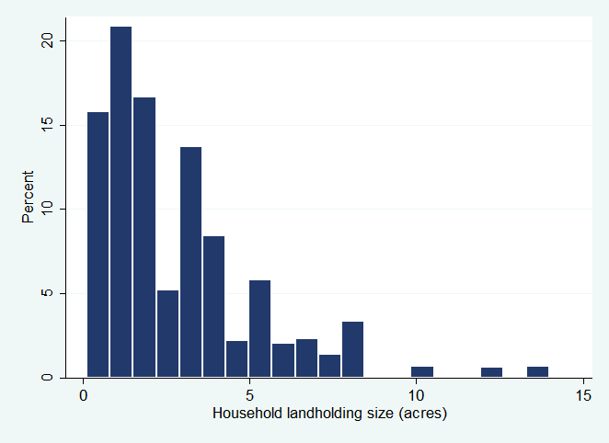

Note: N=140, 1 observation removed from graph for better viewing purposes.

*Figure C.2*: Distribution of Harvested Area Yield for Maize in the Long Rainy Season

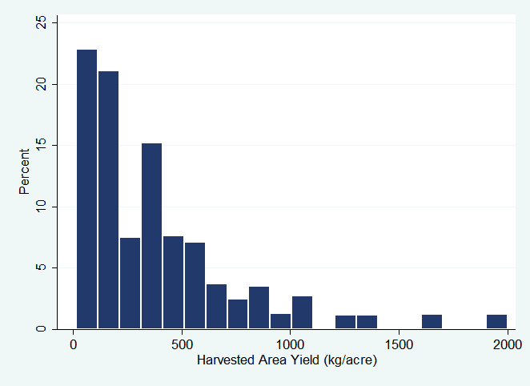

Note: N=83

*Figure C.3*: Distribution of Harvested Area Yield for Beans in the Long Rainy Seasons

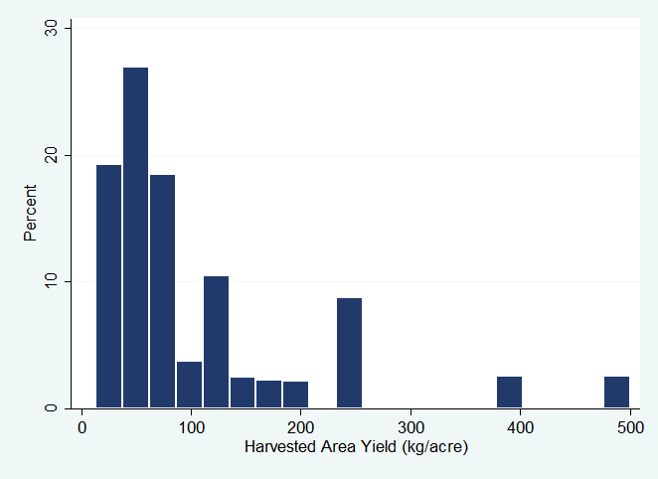

Note: N=45

*Figure C.4*: Distribution of Household Land Productivity (without livestock)

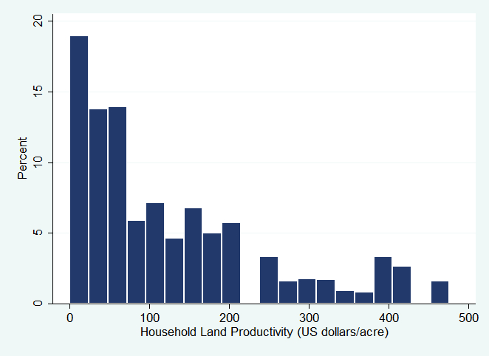

Note: N=119, 9 observation removed from graph for better viewing purposes.

|  |
| --- |
| 1. Supplemental TZNPS Data for the Coastal Sub-Region |

***Figure D.1:* Distribution of Household Landholding Size**

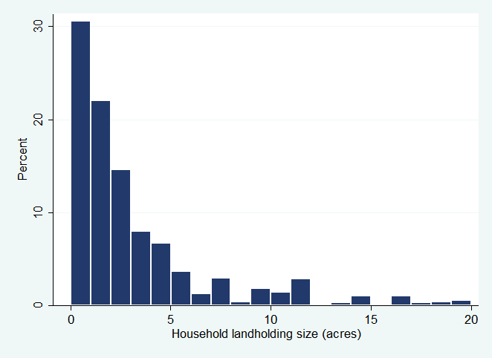

Note: N=261, 3 observations removed from graph for better viewing purposes.

*Figure D.2*: Distribution of Harvested Area Yield for Maize in the Long Rainy Season

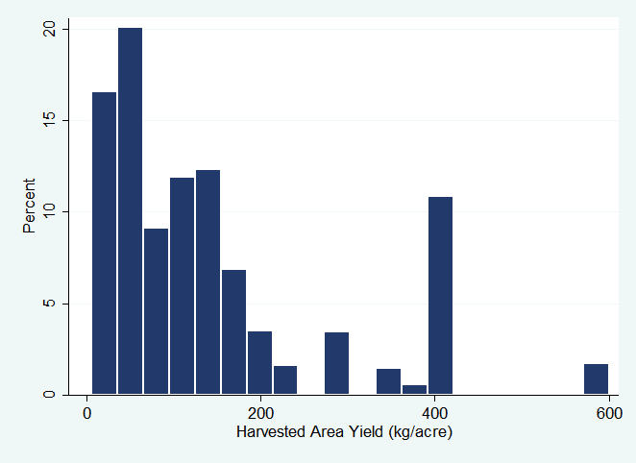

Note: N=50

*Figure D.3*: Distribution of Harvested Area Yield for Cassava Permanent Crop

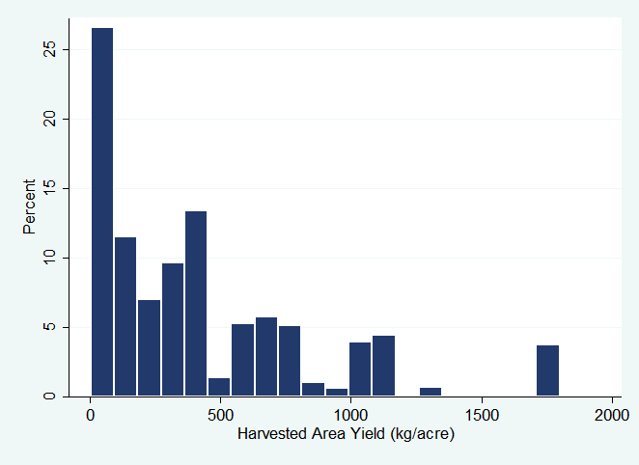

Note N=51

*Figure D.4:* Distribution of Harvested Area Yield for Cassava Permanent Crop for Mainland areas of Coastal Sub-Region

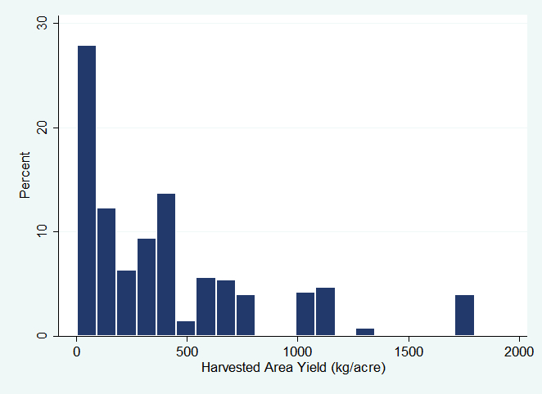

N = 36

*Figure D.5:* Distribution of Harvested Area Yield for Cassava Permanent Crop for Zanzibar Zone

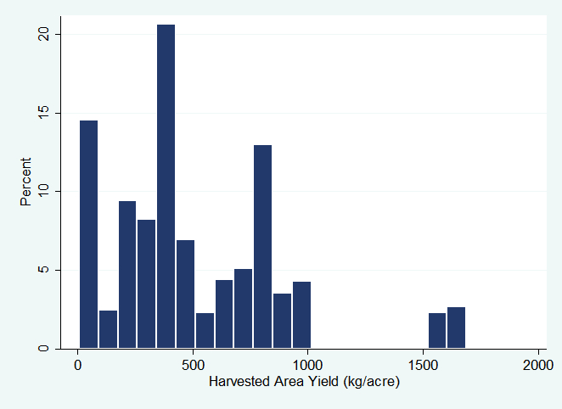

Note: N=38, 2 outlying observations of 3600 and 4000 kg/acre were removed from graph.

*Figure D.6*: Distribution of Harvested Area Yield for Paddy in the Long Rainy Season

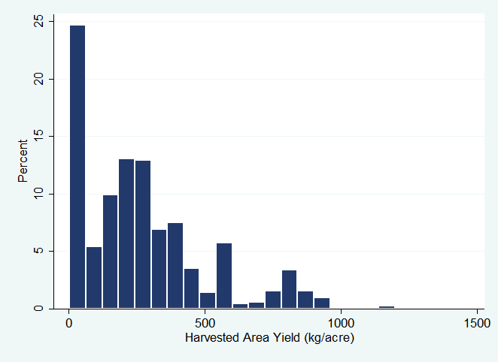

Note: N=84, 1 observation removed from graph for better viewing purposes.

*Figure D.7*: Distribution of Household Land Productivity (without livestock)

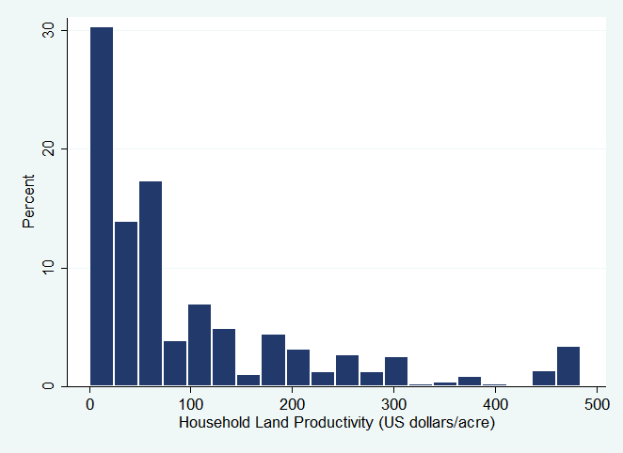

Note: N=229, 7 observation removed from graph for better viewing purposes.

|  |
| --- |
| 1. Supplemental TZNPS Data for the Central Mixed Maize Sub-Region |

*Figure E.1*: Distribution of Household Landholding Size

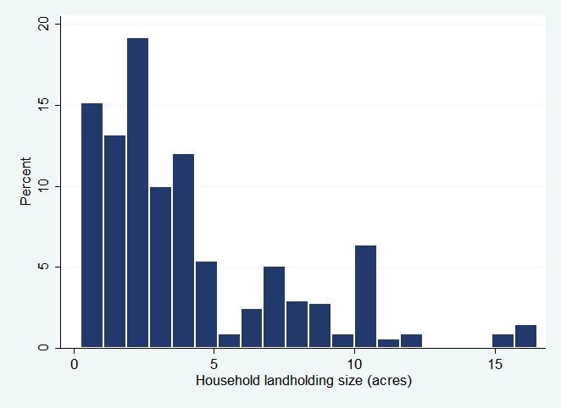

Note: N=118, 2 observations removed from graph for better viewing purposes.

*Figure E.2*: Distribution of Harvested Area Yield for Maize in the Long Rainy Season

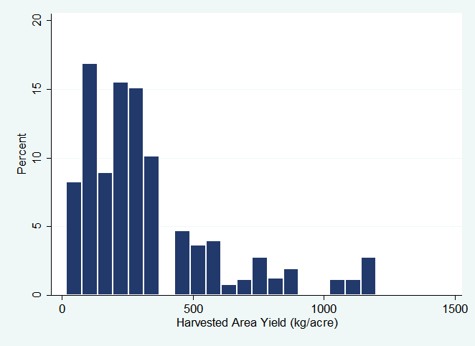

Note: N=83

*Figure E.3*: Distribution of Harvested Area Yield for Paddy in the Long Rainy Season

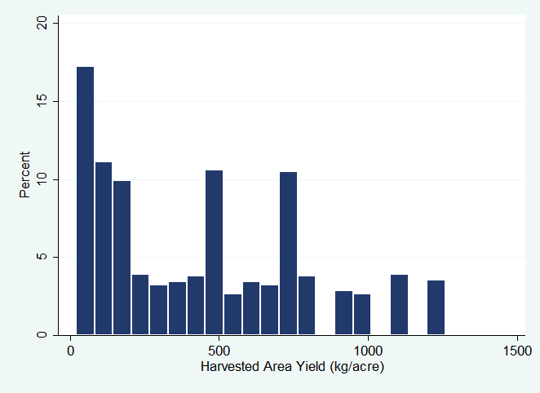

Note: N=30, 1 observation removed from graph for better viewing purposes.

*Figure E.4*: Distribution of Household Land Productivity (without livestock)

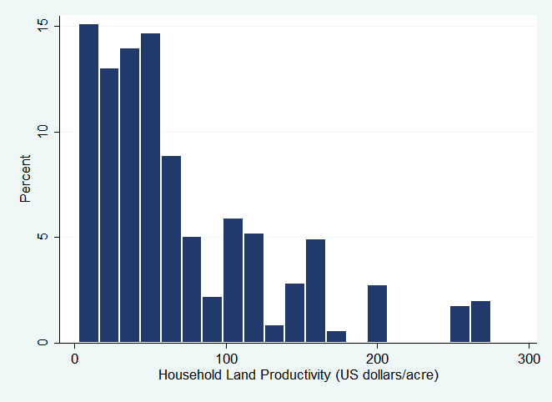

Note: N=108, 1 observation removed from graph for better viewing purposes.

1. The TZNPS data are statistically representative at the national level, so data for the sub-regional level is for general comparison purposes only and does not constitute a statistically valid comparison.
2. <http://www.tanzania.go.tz/agriculture.html>
3. Under intercrop the area actually planted with cassava may be less than the full area of the plot, causing yields to potentially appear lower.
4. This section also includes relevant information from 2013 interviews with farmers in Mtwara and Lindi Regions and staff from IITA, Tanzania Food and Nutrition Centre, and CARE.